STEP 1: AFTER LOGIN TO UBUNTU INSTALL DOCKER

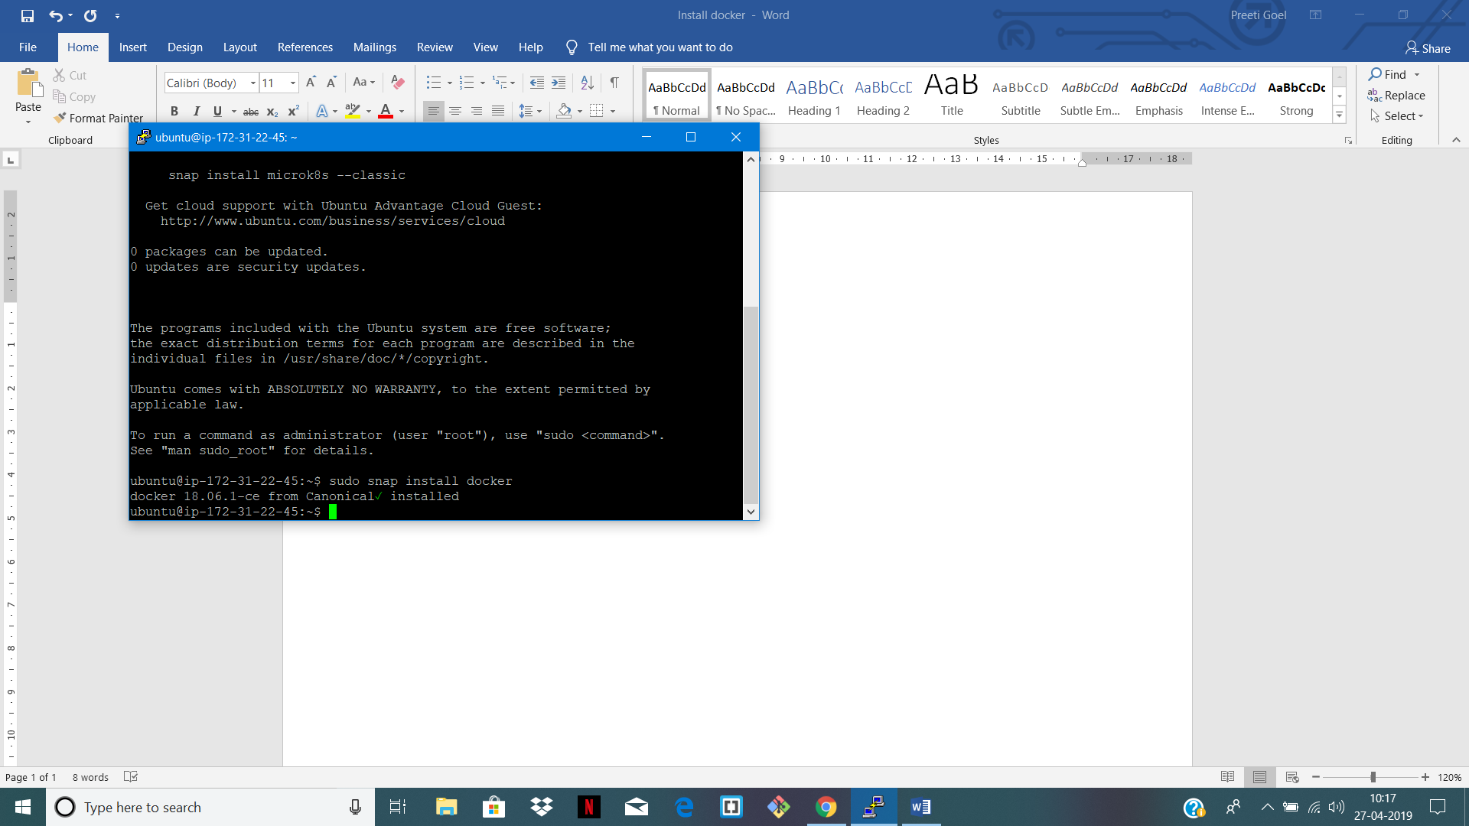

STEP 2: CHECK DOCKER VERION

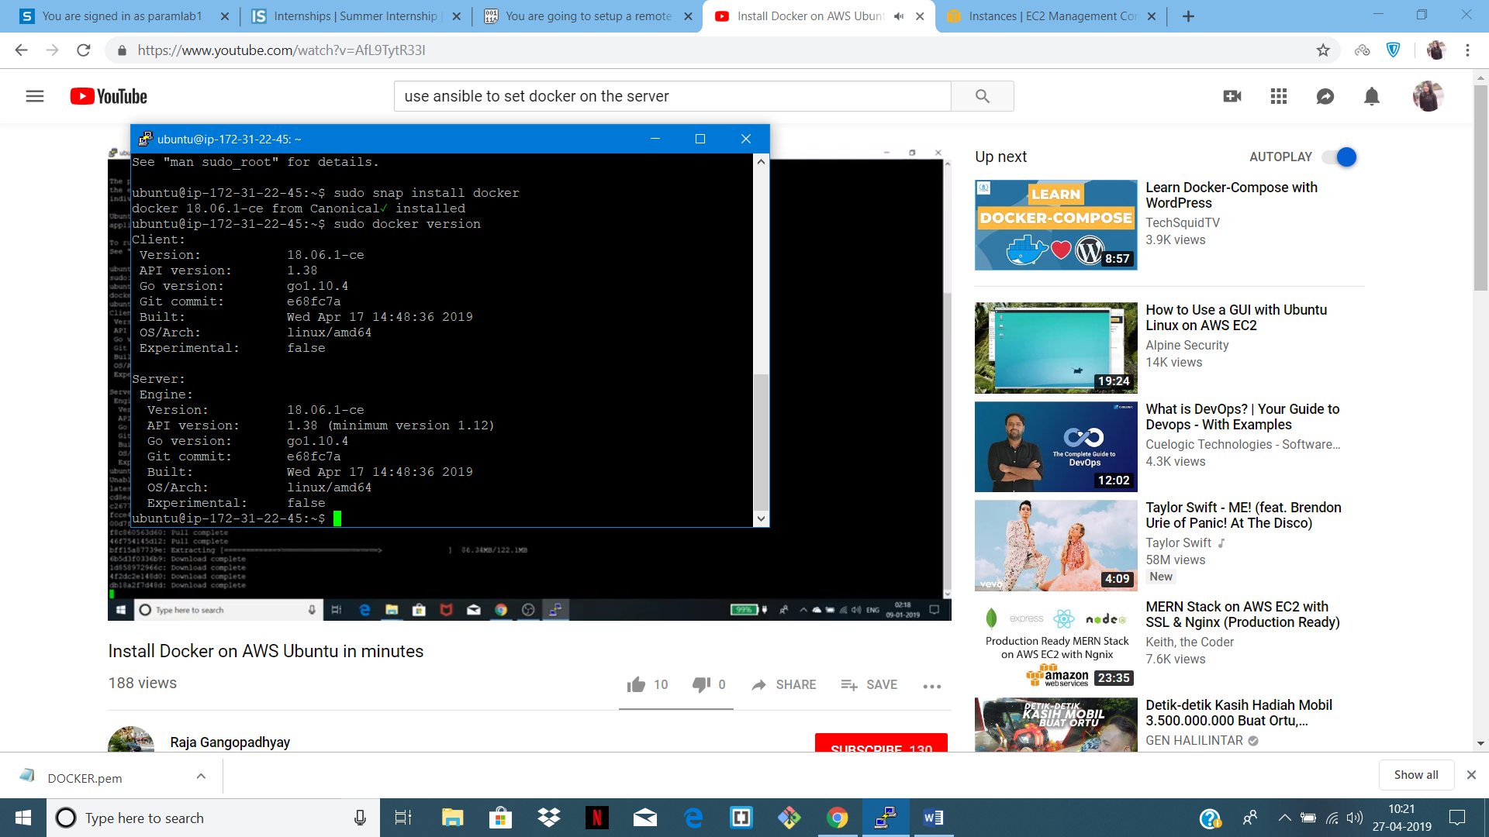

STEP 3: DOWNLOAD IMAGE FOR TOMCAT

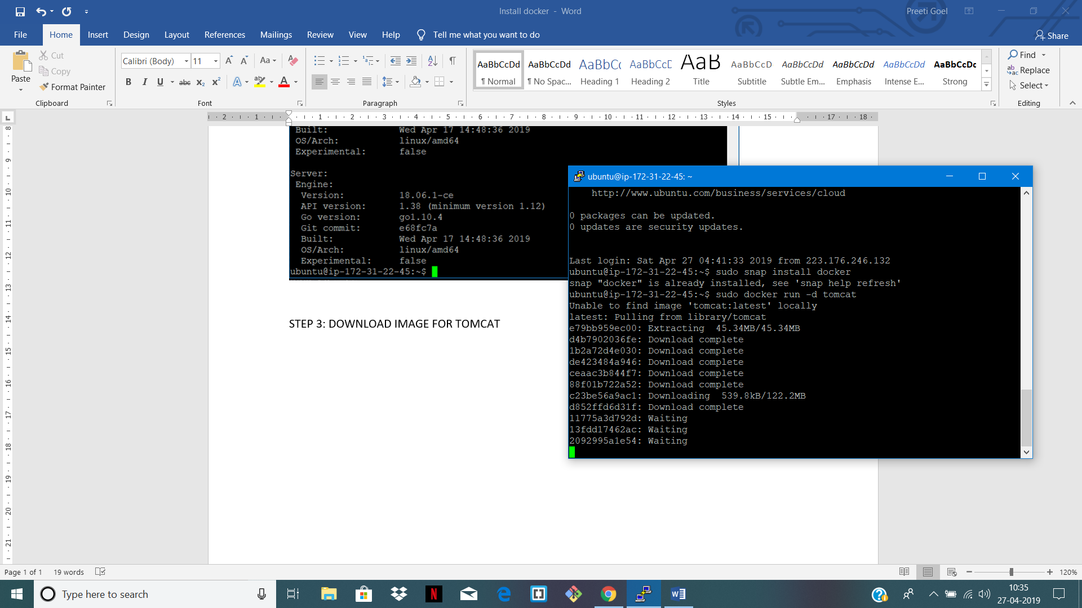

STEP 4: SEE IMAGE UP AND RUNNING

